Git Challenges
- Resolve Merge Conflicts
  - Create a merge conflict intentionally (two users editing the same line).
  - Resolve the conflict and push the changes.

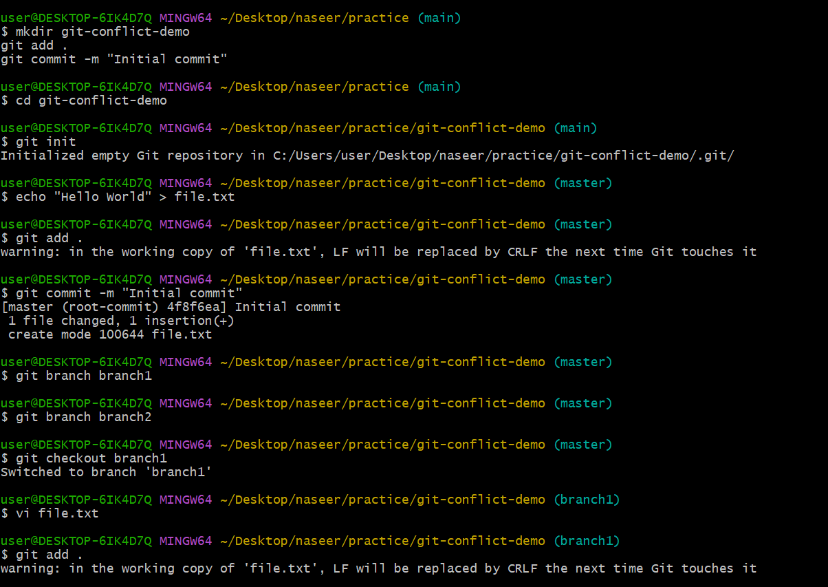
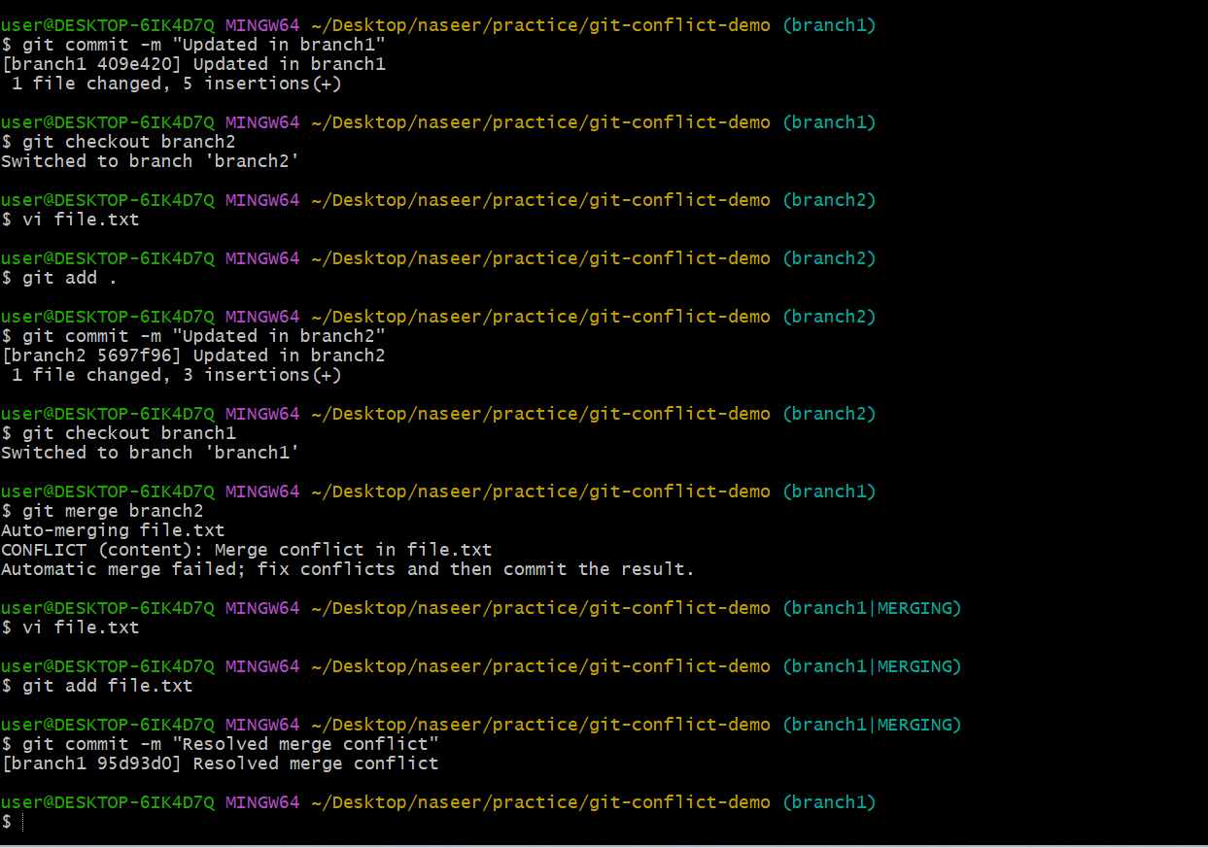

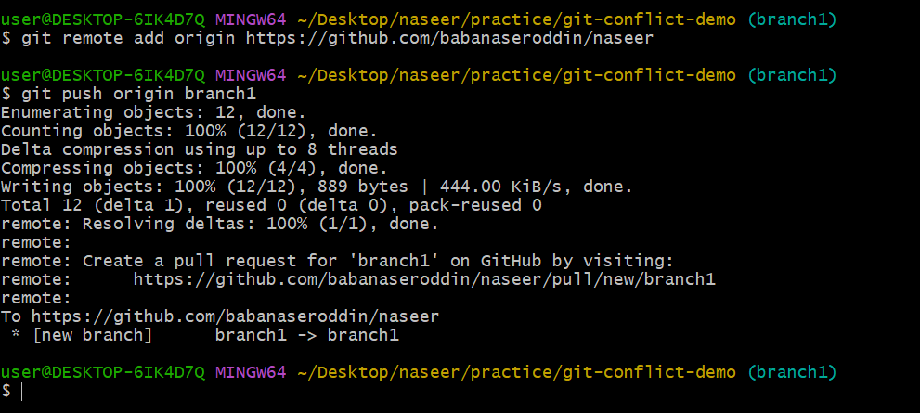

- Recover Deleted Branch
- Delete a local branch and then recover it using the reflog.
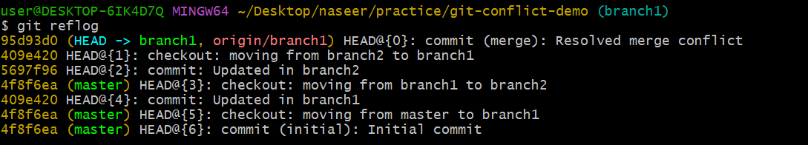
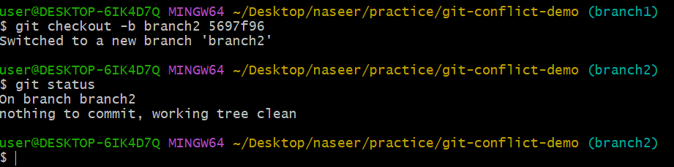
- Undo Wrong Push
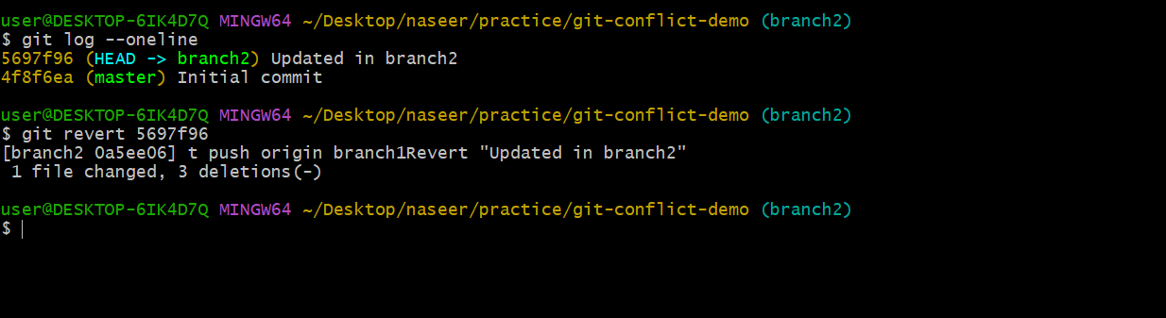
- Push a wrong commit to GitHub, then undo it without losing history.
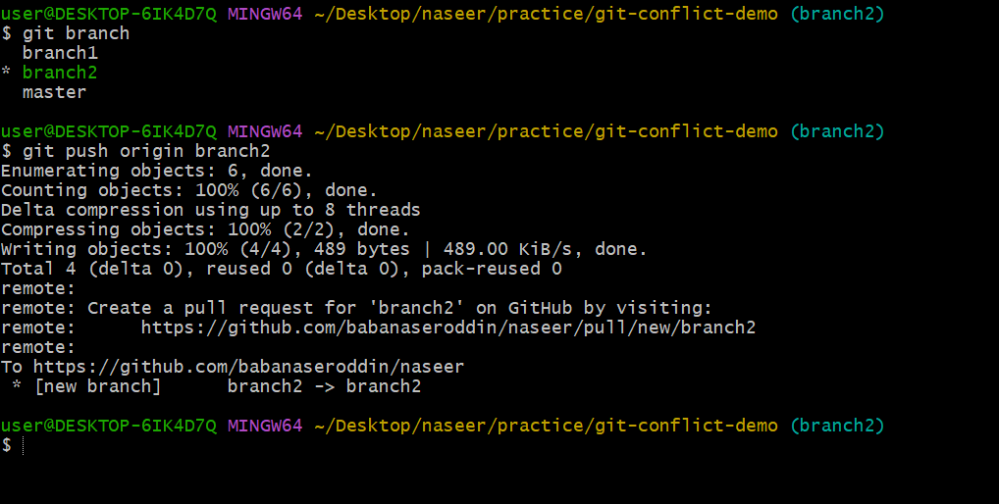
Amend a Commit
- Make a commit, then add a missing file to it using git commit --amend.
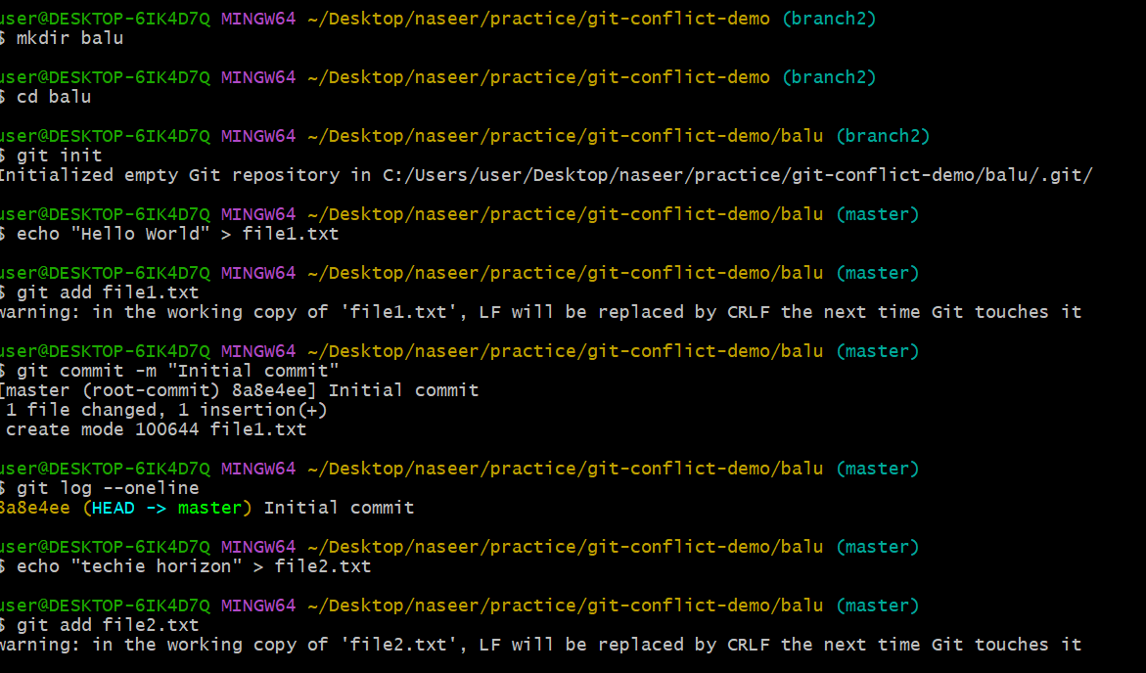
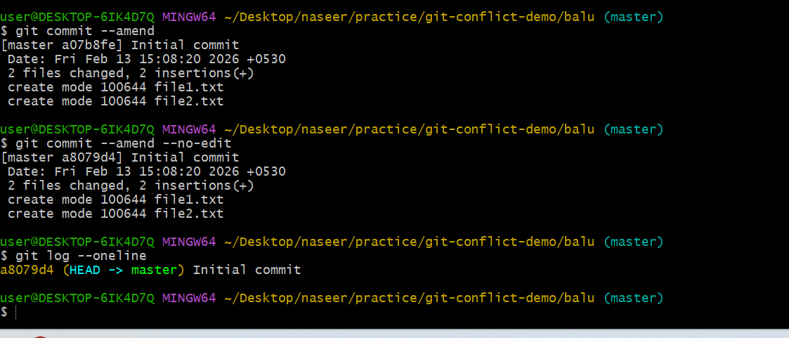

- Cherry-pick a Commit
- Take a specific commit from one branch and apply it to another branch.
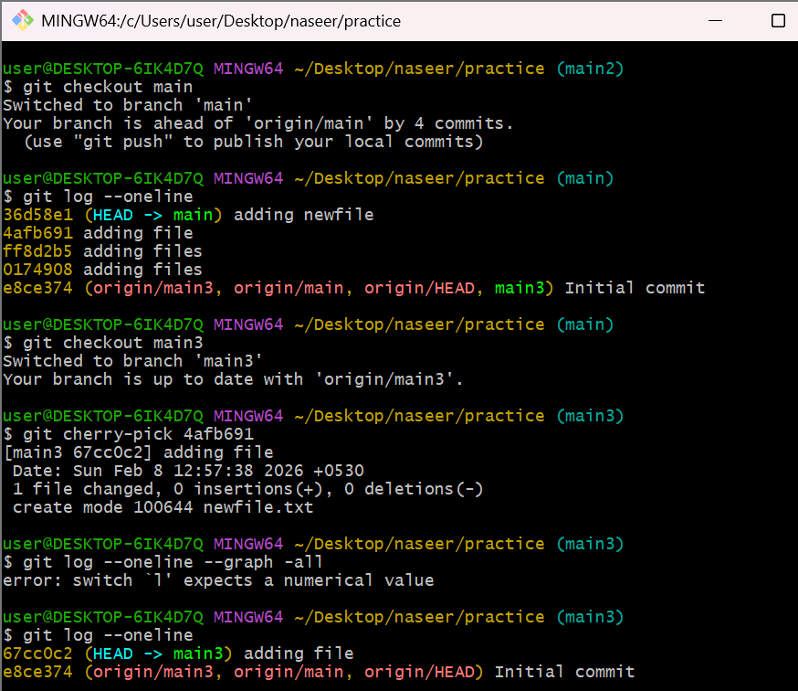

- Interactive Rebase
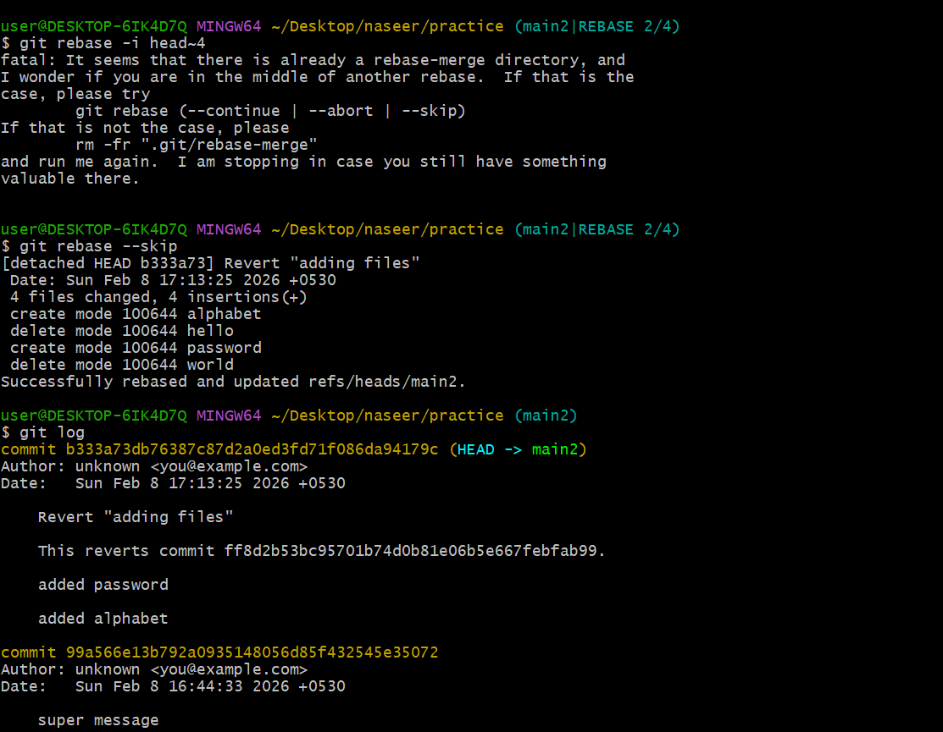
- Reorder and squash multiple commits into a single clean commit.
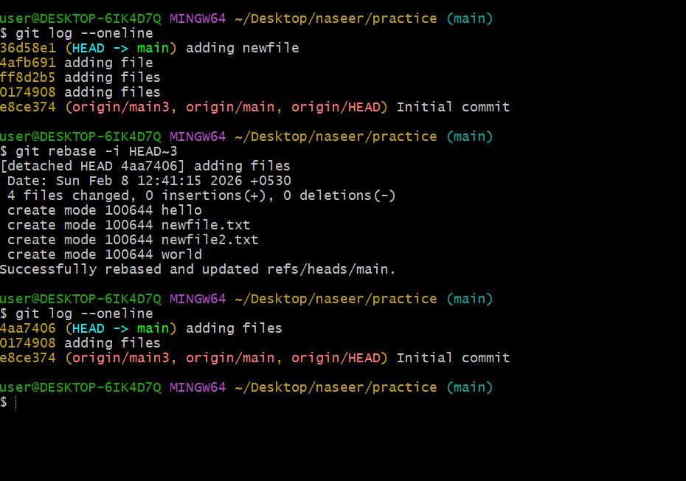
- Tagging & Release
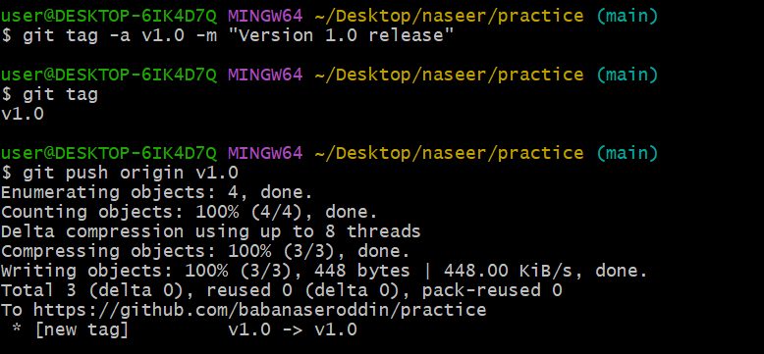
- Create a version tag (v1.0), push it to GitHub, then delete and restore it.
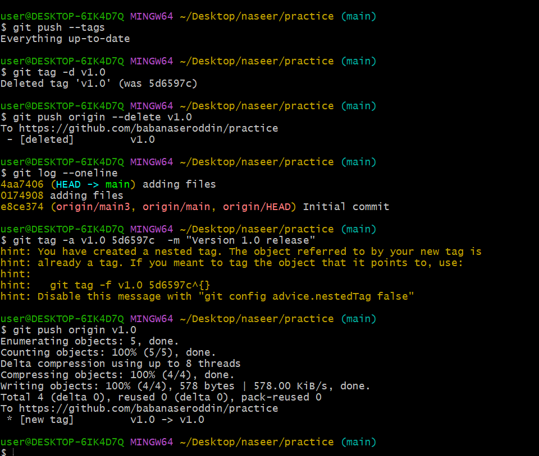
- Clone with Sparse Checkout
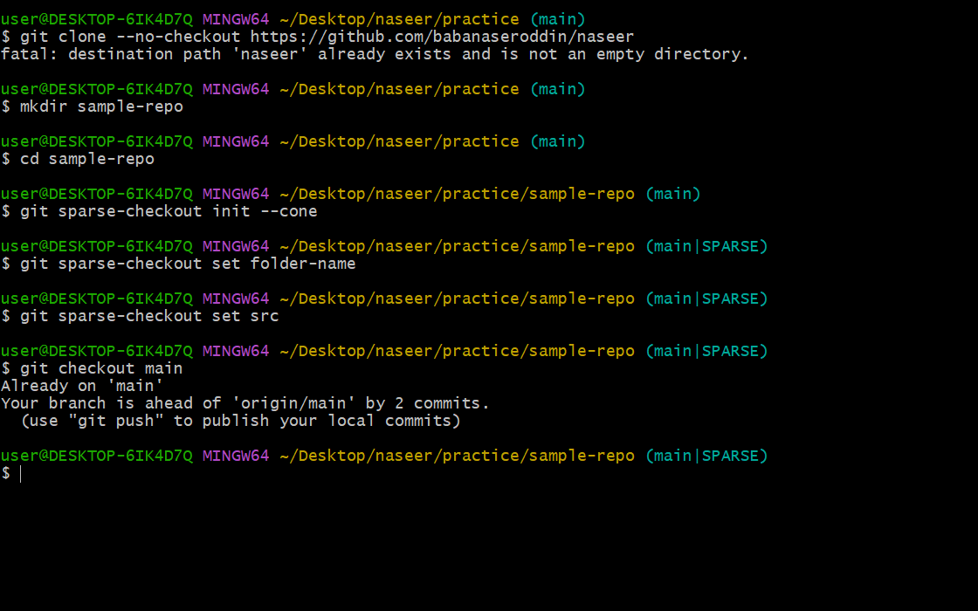
- Clone only a subdirectory of a repo using sparse checkout.
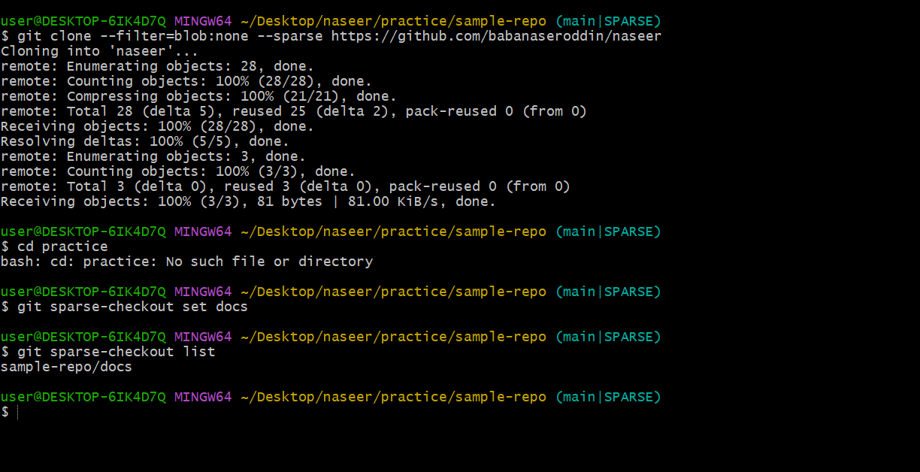

Reset vs Revert Challenge
- Demonstrate the difference between git reset --hard and git revert in a repo.
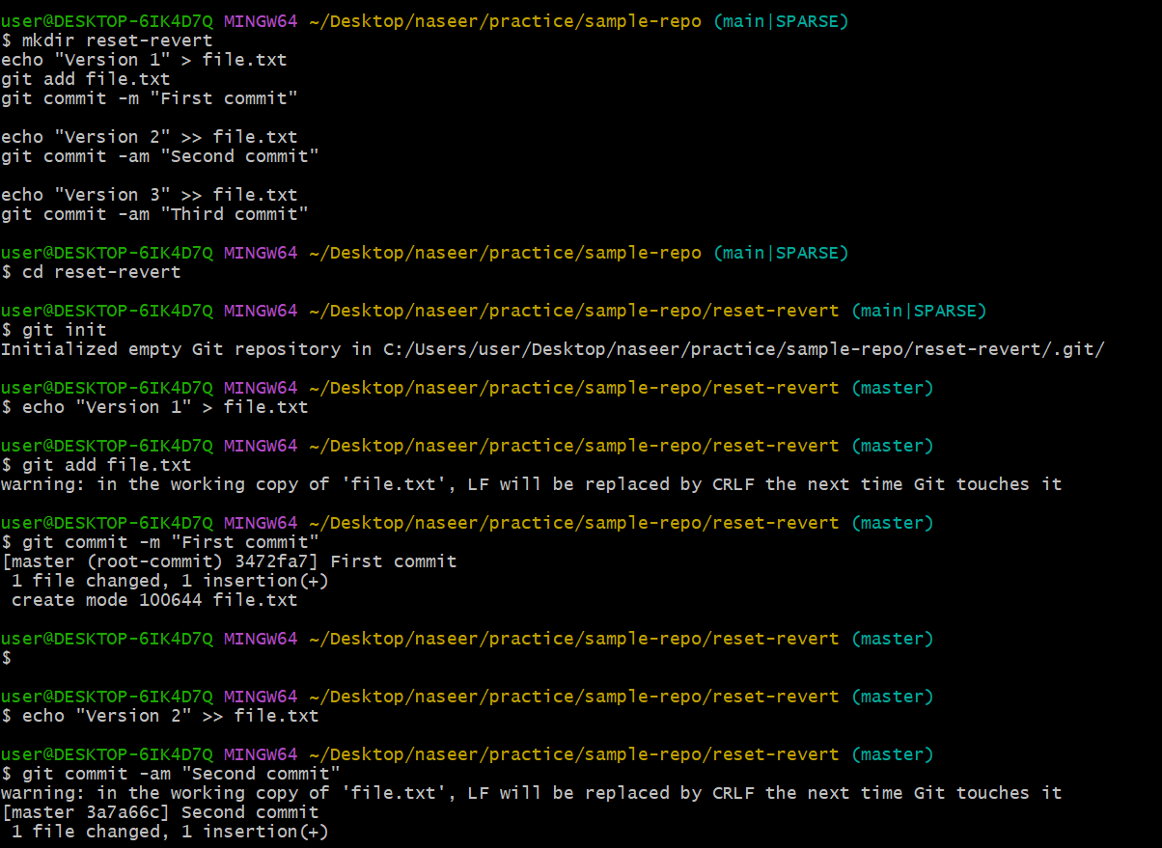
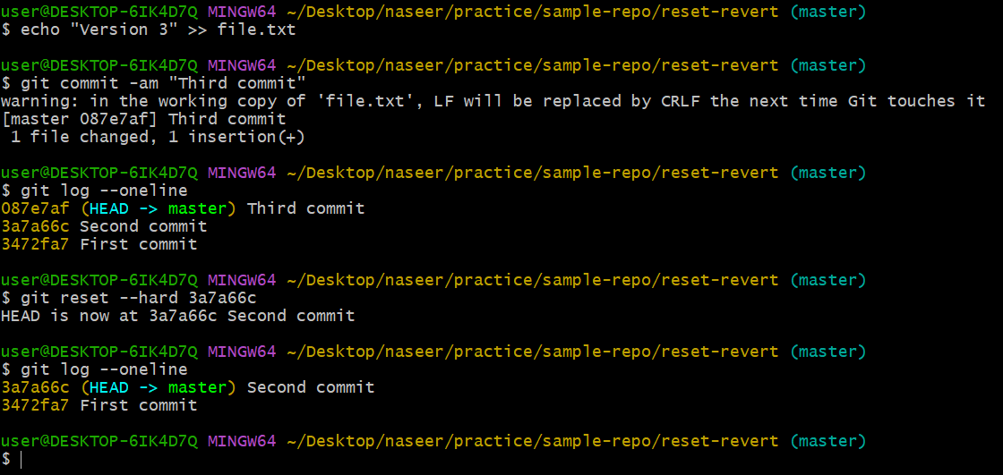
- Detached HEAD Challenge
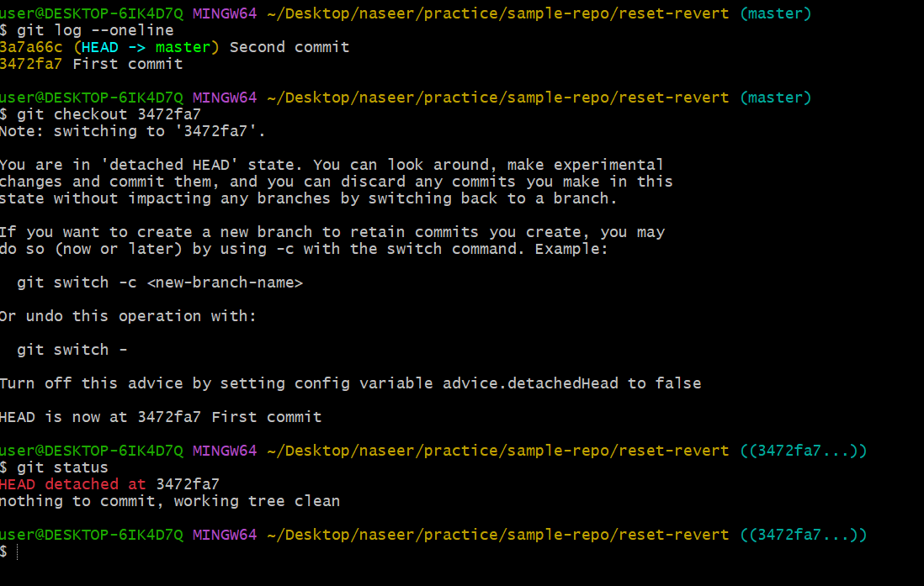
- Checkout a specific commit (detached HEAD state) and create a new branch from it.
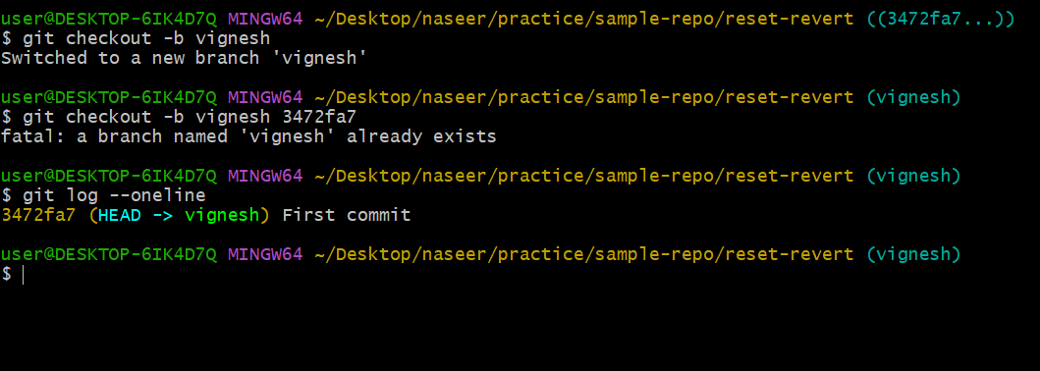

Git Hooks Challenge
- Configure a pre-commit hook to reject commits without a message format (e.g., must start with JIRA-XXX).
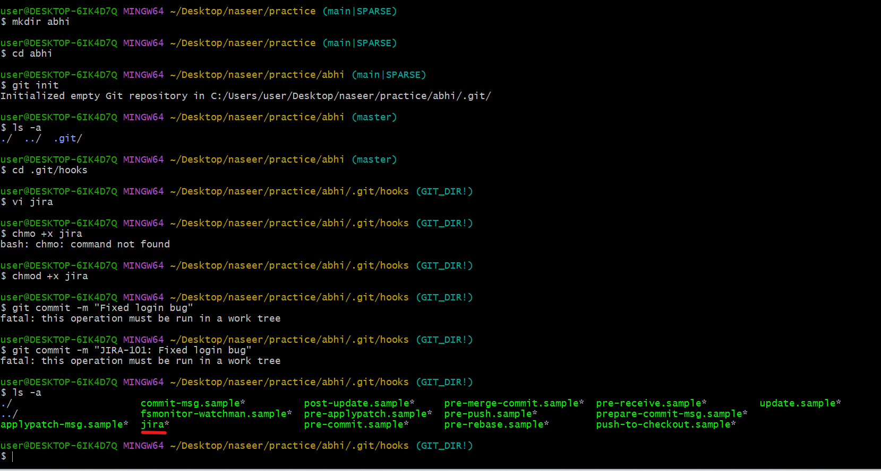
- Squash Merge vs Rebase Merge
Squash Merge: Merging multiple commits into a single commit.
Rebase Merge: Rebase merge is used to merge two different branches
- Show the difference between squash merge and rebase merge with evidence.
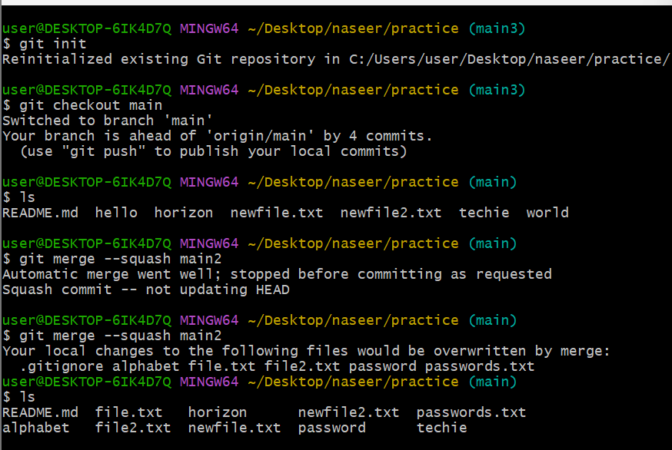
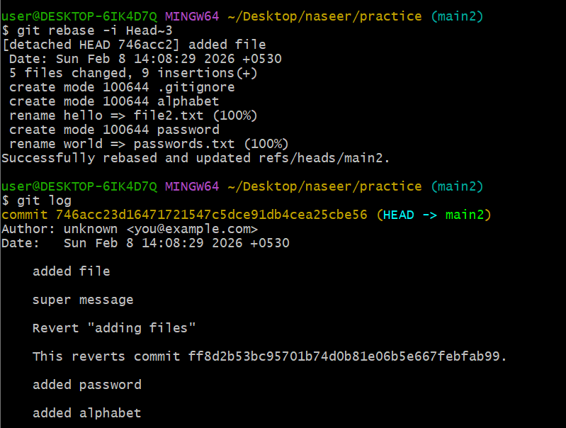
- Fork & Pull Request Workflow
Fork -> clone -> branch -> change -> commit -> push -> pull request -> merge

- Fork a repo, make a change, and submit a pull request to the original repo.
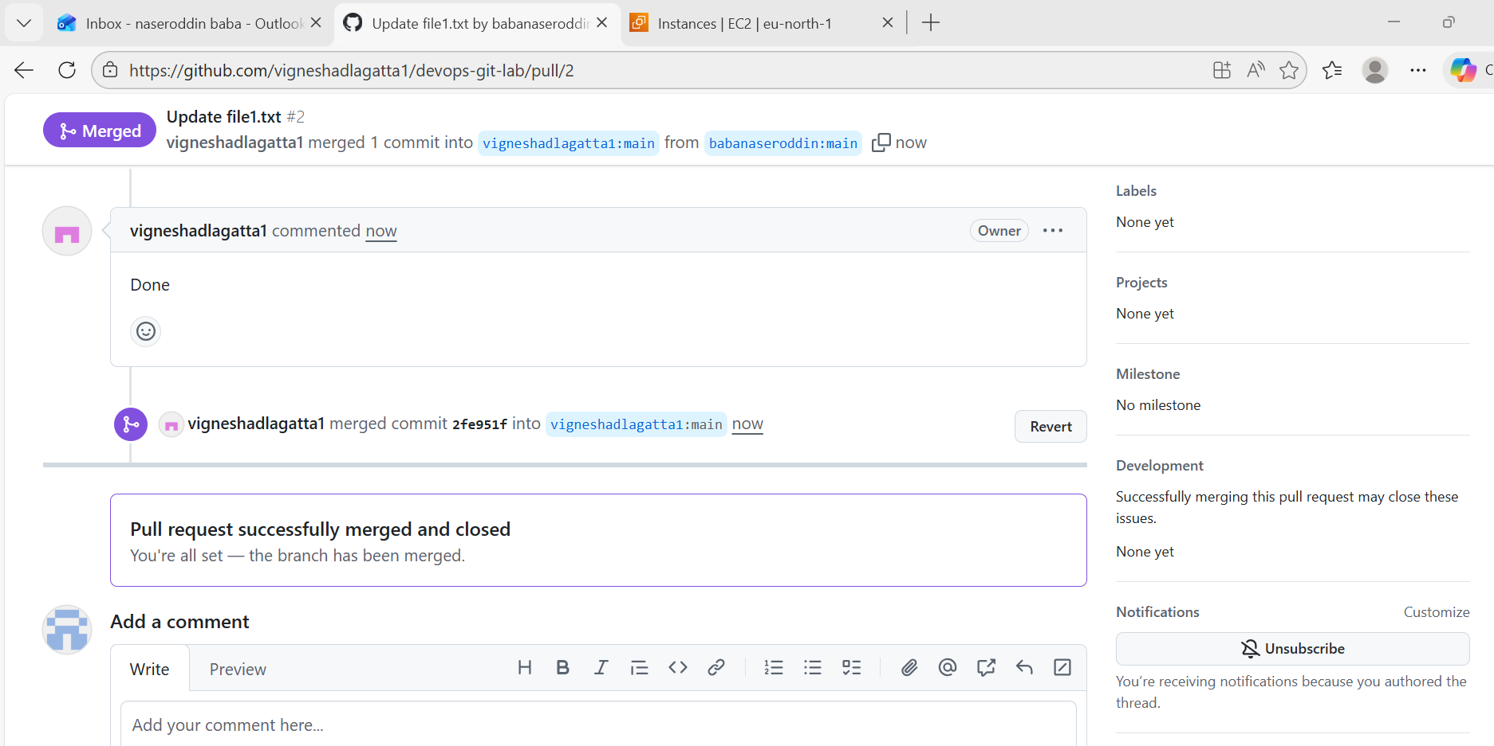
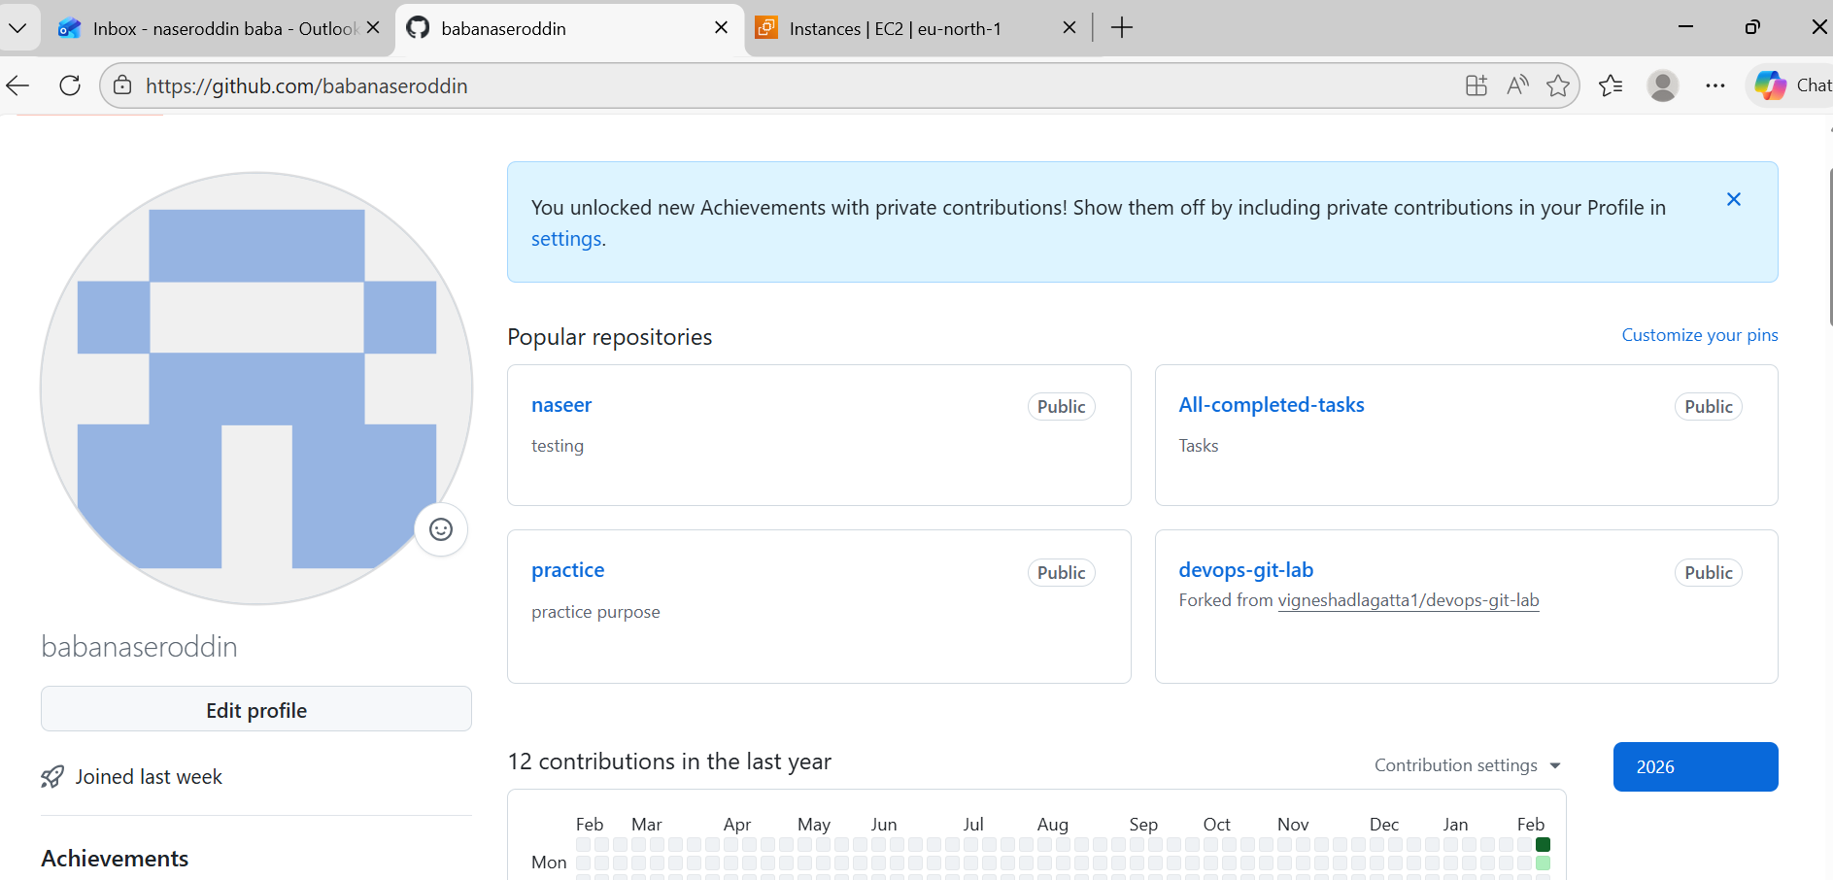

Recover Lost Commit
- Commit something, reset hard, and then recover it using git reflog.
